ENTERPRISE ARCHITECTURE DOCUMENT

Version 0.1 ● <Date>

##### ------------------------------------------------------------------------------------------------------------------------------------------

Using This Template

All chapters of this template should be ideally be addressed, if a chapter or paragraph is not needed, that section/subsection of the document can be marked as Not Applicable but an explanation must be provided as to why it does not apply.

# ENTERPRISE ARCHITECTURE DOCUMENT

**[Clients Name]**

[PROJECT NAME]

|  |  |
| --- | --- |
| VERSION: [Version Number] | REVISION DATE: [Date] |

Approval of the Enterprise Architecture indicates an understanding of the purpose and content described in this deliverable. By signing this deliverable, each individual agrees with the content contained in this deliverable.

|  |  |  |  |
| --- | --- | --- | --- |
| **Approver Name** | **Title** | **Signature** | **Date** |
|  |  |  |  |
|  |  |  |  |
|  |  |  |  |
|  |  |  |  |
|  |  |  |  |

**Contents**

CHAPTER 1 MANAGEMENT SUMMARY 3

CHAPTER 2 INTRODUCTION 5

1.1 Document Scope 5

CHAPTER 3 STRATEGY AND BUSINESS MODEL 6

* 1. Strategy 6
  2. Business Model 6

CHAPTER 4 OVERALL ENTERPRISE ARCHITECTURE 7

* 1. Enterprise Architecture Context Diagram 7
  2. Enterprise Architecture Model 7
     1. Overall Architectural Considerations 7
  3. Enterprise Architecture Concepts Overview and Definitions 7
  4. Enterprise Architecture Principles Overview and Definitions 8
  5. Enterprise Architecture Building Blocks Overview and Definitions 8
  6. Enterprise Architecture Element Definitions 8
  7. Enterprise Architecture Component Definitions 8
     1. Enterprise Architecture Component A 8
     2. Enterprise Architecture Component B 9

CHAPTER 5 ARCHITECTURES 10

* 1. Business Architecture 10
  2. Information Architecture 10
  3. Application Architecture 10
  4. Technical Architecture 10

CHAPTER 6 ENTERPRISE ARCHITECTURE DESIGN 11

* 1. Enterprise Architecture Component A 11
     1. Component Functions 11
     2. Technical Considerations 11
     3. Selected Product(s) 11
     4. Selection Rationale 11
     5. Architecture Risks 11

## Chapter 1 MANAGEMENT SUMMARY

*This chapter introduces the Enterprise Architecture itself, by means of listing the top 10 Architecture Principles and the impact they have on the products, processes, and projects of the company.*

Hello dear reader,

Before you lies the Enterprise Architecture of <Client Name>. Enterprise architecture is a conceptual blueprint of the organization. Meaning it is a set of views and visualizations of the current state and future state of the organization and the roadmap to get there.

This document is aimed at all managers, projects and project workers in the company. In fact, this document is aimed at everyone that is helping with the change and transformation in the organization.

This Enterprise Architecture will realize five benefits year by year:

1. IT Cost Reduction and Rationalization
2. Business Process Improvement
3. Standardization
4. Strategy Realization
5. Innovation Enablement

Based on the strategy and the business model of <CLIENT NAME> the Enterprise Architecture can be summarized in 10 Architecture Concepts and Architecture Principles. By helping to implement these concepts and their principles, you will help to realize the 5 benefits of EA. And the better these concepts and principles are implemented, the sooner the organization will reach its future state and be more competitive (stronger), efficient (functional) and innovative (beautiful).

Architecture Concept 1:

Architecture Principle 1:

Architecture Concept 2:

Architecture Principle 2:

Architecture Concept 3:

Architecture Principle 3:

Architecture Concept 4:

Architecture Principle 4:

Architecture Concept 5:

Architecture Principle 5:

Architecture Concept 6:

Architecture Principle 6:

Architecture Concept 7:

Architecture Principle 7:

Architecture Concept 8:

Architecture Principle 8:

Architecture Concept 9:

Architecture Principle 9:

Architecture Concept 10:

Architecture Principle 10:

## Chapter 2 Introduction

*This chapter introduces the Enterprise Architecture Document. It says why this document was*

### 1.1 Document Scope

***Document Scope*** *describes the context and the goals of this document in a narrative.*

*Example:*

###### Enterprise Architecture and Business Requirements

This document describes the Enterprise Architecture for **<CLIENT NAME>.** This Enterprise Architecture (EA) satisfies the business requirements from the stakeholders as documented in the Business Requirements Document, <Date>, and summarized in chapter <Number> and implements the functionality and satisfies technical, operational and transitional requirements described in the Functional Specification, <Date>. Also summarized in Chapter <number>

The goal of this Enterprise Architecture document is to define the products, processes, information flows, applications, data, technologies, technical products, and techniques necessary to develop and support the future state organization/company, and to ensure that the organization elements/components are compatible and comply with the enterprise-wide standards and direction defined by the Owner/Client and Architecture Board.

This document will also:

* Identify and explain the risks inherent in this Enterprise Architecture; Define baseline sizing, archiving and performance requirements;
* Identify the hardware and software specifications for the Development, Testing, QA and Production environments.
* Define procedures for both data and code migration among the environments.

###### Architecture Repository

All the data, models, views and visualizations used in this document are stored in the companies Architecture Repository.

###### Architecture Dossier

References fragments of and references to other architecture documents. These documents are all part of the architecture dossier of the company. The documents are created with the data, models, views, and visualizations from the Architecture Repository.

###### Architecture Center

For all stakeholders and projects in the company, there is an Architecture Center on the companies intranet. It is a set of webpages that publish and provide the architecture visualizations and architecture documents that everyone should have access to. It is these documents that support decision making of stakeholders and guides the work done in the innovation projects.

## Chapter 3 Strategy and Business Model

*This chapter describes and visualizes the current and future strategy and business model of the organization.*

### Strategy

The organization has a current state and future state strategy. The strategy of the organization is set yearly by the board of directors. New technologies, trends, shifts in the interest of market and client, demographics and sociologic changes all have impact on and influence the new strategy.

For the upcoming <n> years the organization has the following strategy:

<strategy map>

For the past <n> year, the organization has the following strategy:

<strategy map>

The following parts of the strategy were not realized:

<list issues>

### Business Model

The organization has a current state and future state business model. The business model is set yearly by the board of directors together with the management team.

For the coming upcoming <n> years the organization has actually two business models for <m> different market. In this document we will only show one of these business models:

<business model canvas>

Below you can see the current state business model:

<business model canvas>

## Chapter 4 OVERALL ENTERPRISE ARCHITECTURE

### Enterprise Architecture Context Diagram

The **Enterprise Architecture Context Diagram** provides the “big picture” view of the enterprise’s architecture, and puts it in context with the rest collaborating organizations, illustrating how the organization's elements & components fit into the existing environment.

### Enterprise Architecture Model

The **Enterprise Architecture Model** represents the various architecture concepts, principles, building blocks, patterns, elements, components, rules and standards that comprise the organization, and shows their interrelationships.

#### Overall Architectural Considerations

*The* ***Overall Architectural Considerations*** *section defines how additional technical requirements have been addressed by the architecture. Representative items in this section may include:*

### Enterprise Architecture Concepts Overview and Definitions

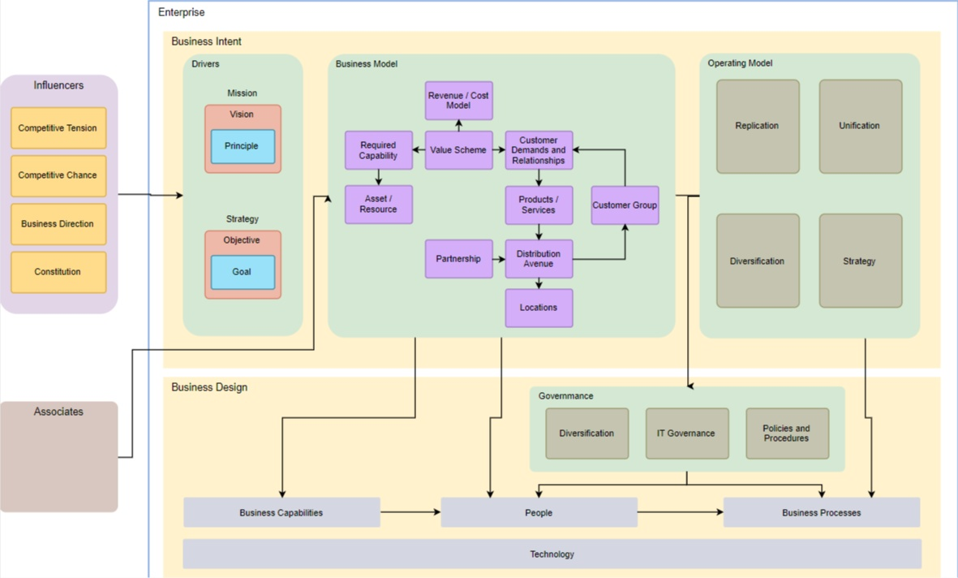

### Enterprise Architecture Principles Overview and Definitions

### Enterprise Architecture Building Blocks Overview and Definitions

### Enterprise Architecture Element Definitions

### Enterprise Architecture Component Definitions

#### Enterprise Architecture Component A

The **Architecture Component Definitions** section provides a narrative describing and explaining each architecture component in the Enterprise Architecture Model, and identifies specific elements that comprise that component in this system. The following are examples of architecture components and elements:

|  |  |
| --- | --- |
| **Enterprise Architecture Component** | **Component Parts** |
| Process | Task |

|  |  |
| --- | --- |
|  | Input  Output Indicator |
| Application | Interface Module Activity |

#### Enterprise Architecture Component B

## 

## Chapter 5 ARCHITECTURES

*Here follows a description and visualization of the architectures that are part of the architecture framework*

### Business Architecture

### Information Architecture

### Application Architecture

### Technical Architecture

## Chapter 6 ENTERPRISE ARCHITECTURE DESIGN

*The* ***Enterprise Architecture Design*** *section provides detailed descriptions of each product implementing architecture components and explains the rationale for product selection.*

### Enterprise Architecture Component A

#### Component Functions

* + 1. **Technical Considerations**
    2. **Selected Product(s)**
    3. **Selection Rationale**
    4. **Architecture Risks**